**Create a employee table in Mysql and columns as Emp_id, Emp_name, Dept_name(Hadoop Developer), Emp_sal.**

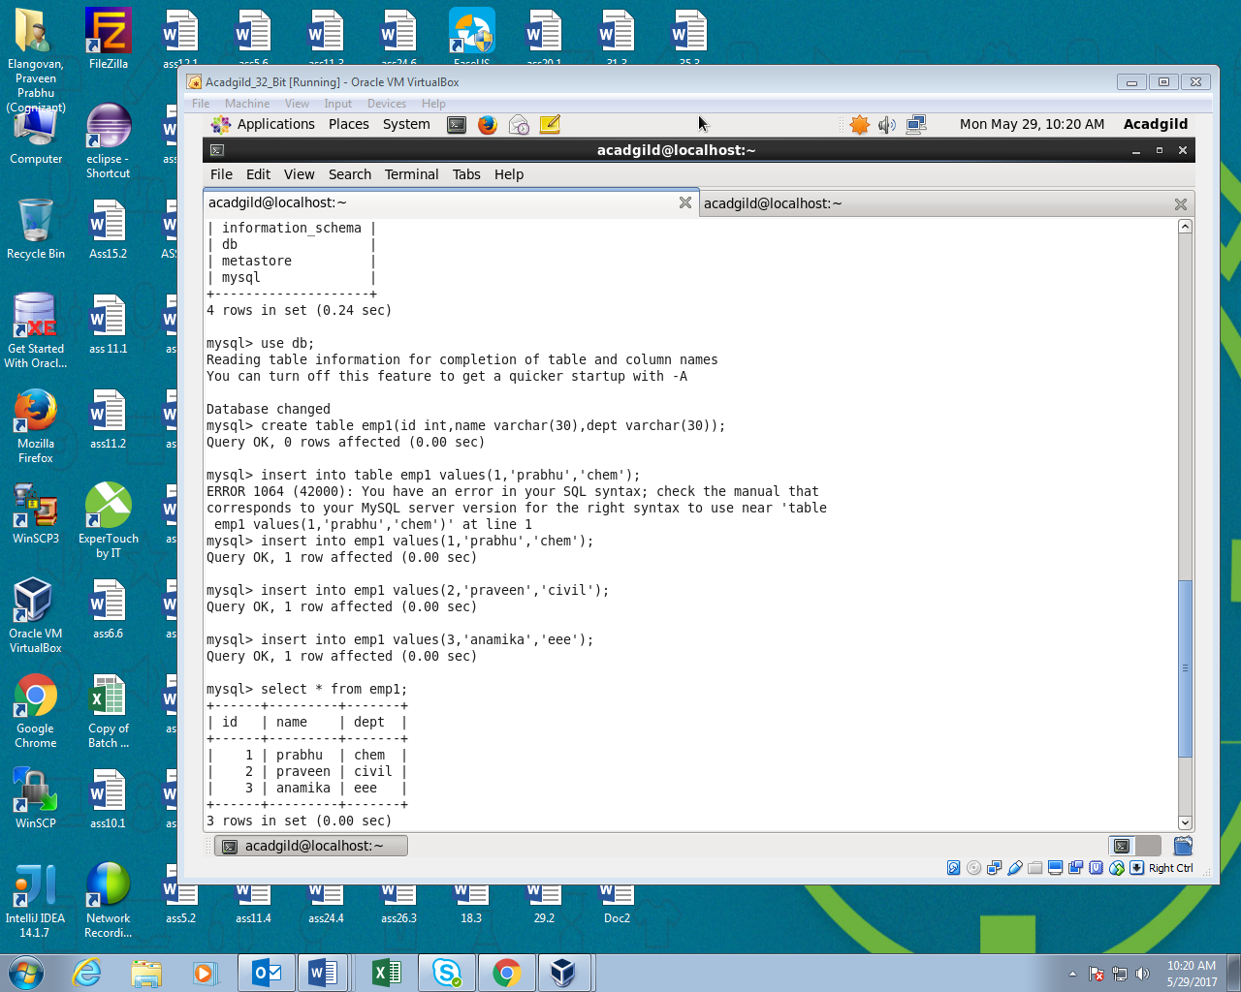

**Importing data from mysql to hdfs:**

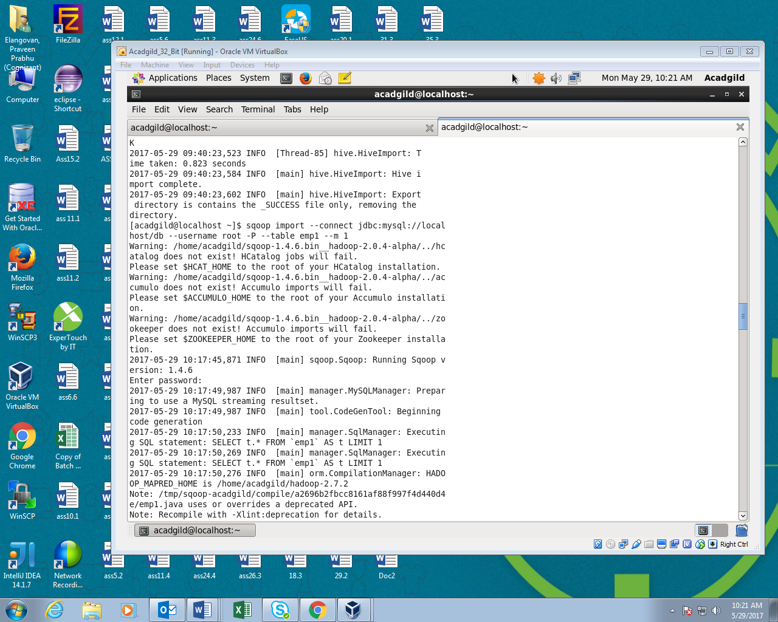

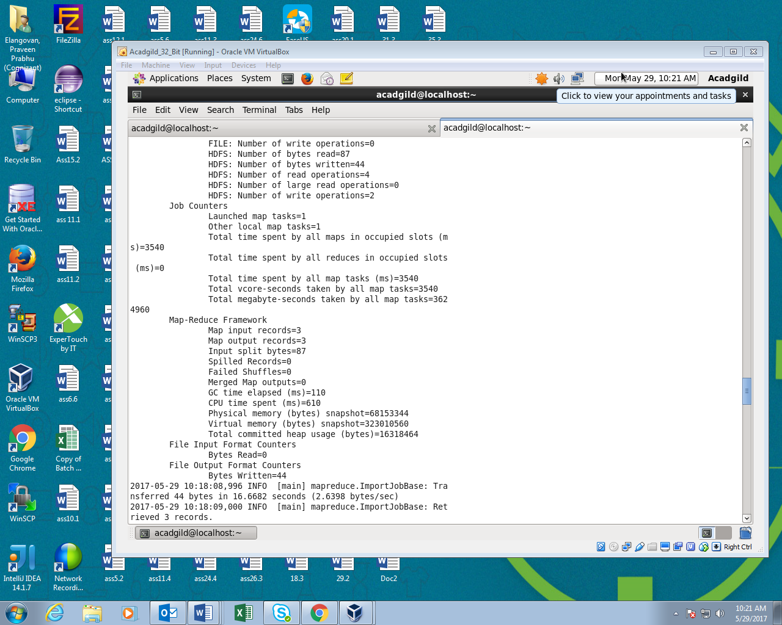

**Output:**

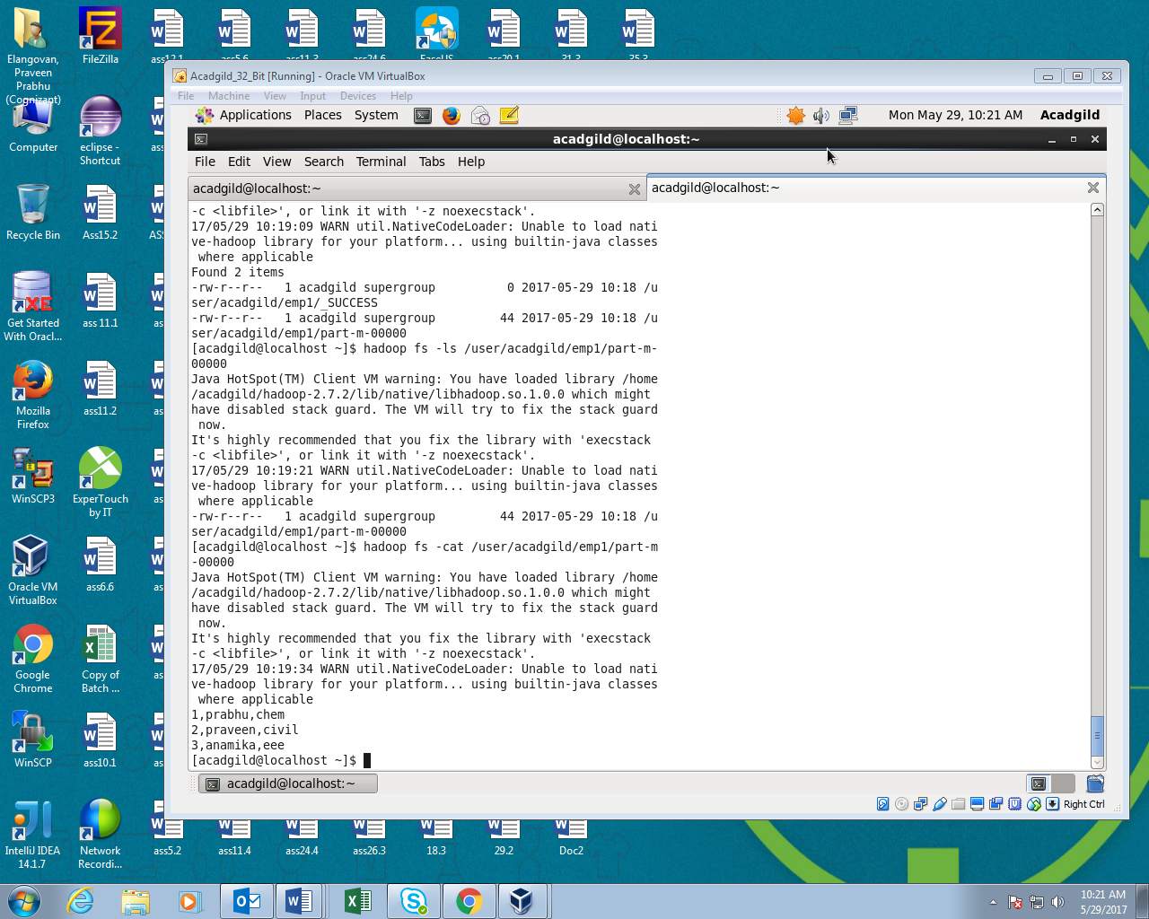

**2. Create a employee2 table in Mysql Emp_name and Emp_sal from HDFS directory to Mysql table employee2 using Sqoop.**

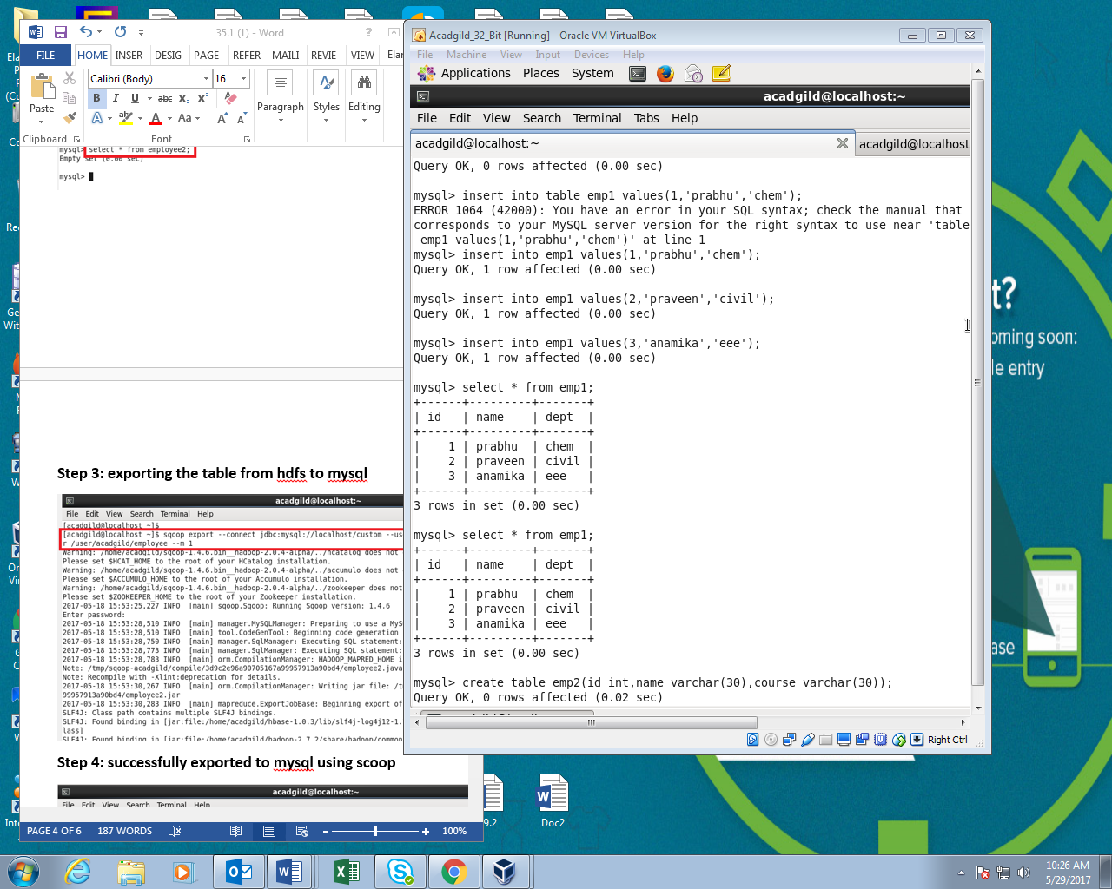

**Exporting data from hdfs to mysql using sqoop:**

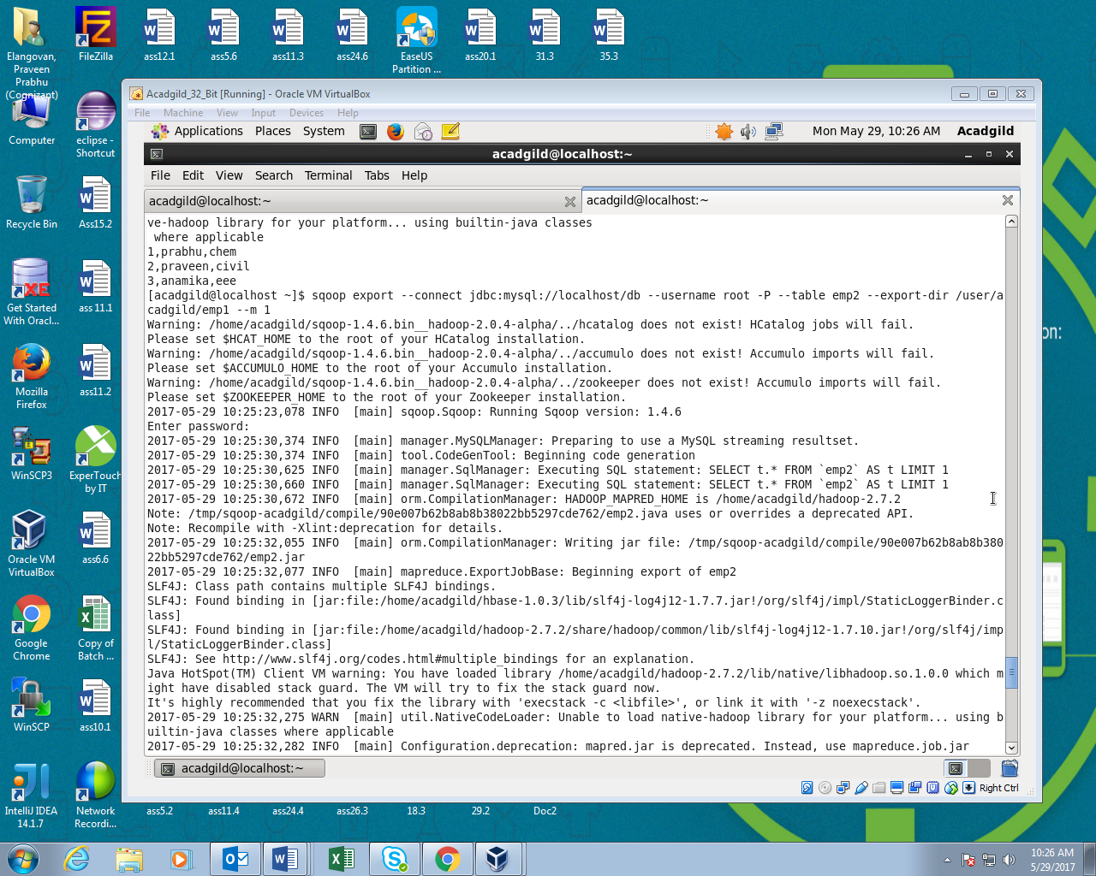

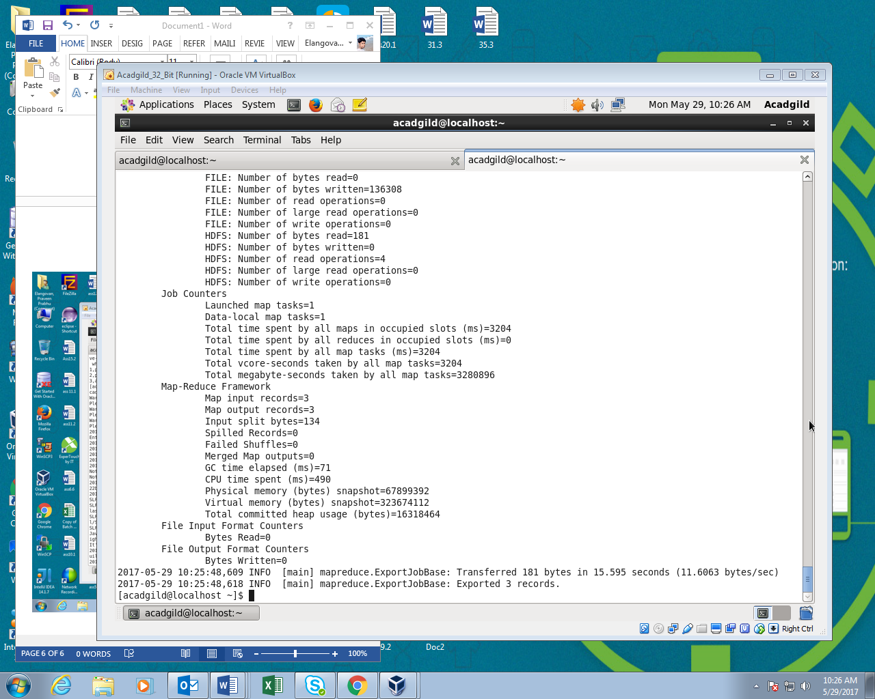

**Output:**

